Project 2:
Aws Advance Lu Batch 2:
Deploying Amazon RDS Multi-AZ and Read Replica, Simulate Failover
Lab Details
- This lab walks you through the steps to launch an Amazon Aurora RDS DB instance with multi-AZ enabled. We will also simulate a database failover from one AZ to another.
- You will practice using Amazon Aurora.
- Duration: 1 hour
- AWS Region: US East (N. Virginia) us-east-1
Lab Tasks
- In this lab session, first we are going to launch an Amazon Aurora RDS DB instance with Multi-AZ enabled.
- Connect to the RDS database instance (using its endpoint) from your local machine.
- Create a test database and table in your Master RDS DB instance.
- Force the Master DB instance to failover.
- After Failover, Master will change to Reader and Reader will change to Master
- Connect to the new Master to test the database replication. 
Steps
Creating an EC2 Instance
- Click on
- Choose an Amazon Machine Image (AMI): Search for Amazon Linux 2 AMI in the search box and click on the select button
- Choose an Instance Type: Select and then click on the .
- On the Configure Instance Details page:
- Network: Select default available VPC
- Subnet : Default selected
- Auto-assign Public IP : Enable - It should be enabled because the public IP is needed for connecting to EC2 via SSH.
- Click on .
- Under the User data section, enter the following script, (which installs MySQL):
#!/bin/bash -ex
yum install mysql -y
- Now click on
- Add Storage Page : No need to change anything in this step. Click on .
- Add Tags Page
- Click on
- Key : Name
- Value : MyRdsEc2server
- Click on
- On the Configure Security Group page:
- Assign a security group: Create a new security group
- Security group name: MyEc2server-SG
- Description: Security for ec2 server to connect with RDS
- To add SSH:
- Choose Type:
- Source: Custom Enter 0.0.0.0/0 in the textbox or select Anywhere .
- Review and Launch : Review all your settings and click on .
- Key Pair - Select Create a new key Pair with name MySSHKey, click on and save it to your local machine.
- Once the download is complete, click on .
- After 1-2 minutes, the Instance State will become running as shown below:
- Note down IPv4 Private IP address in your text editor, navigate to the EC2 Dashboard and look in the instance details.
ScreenShot for Ec2 Console with the instance details:
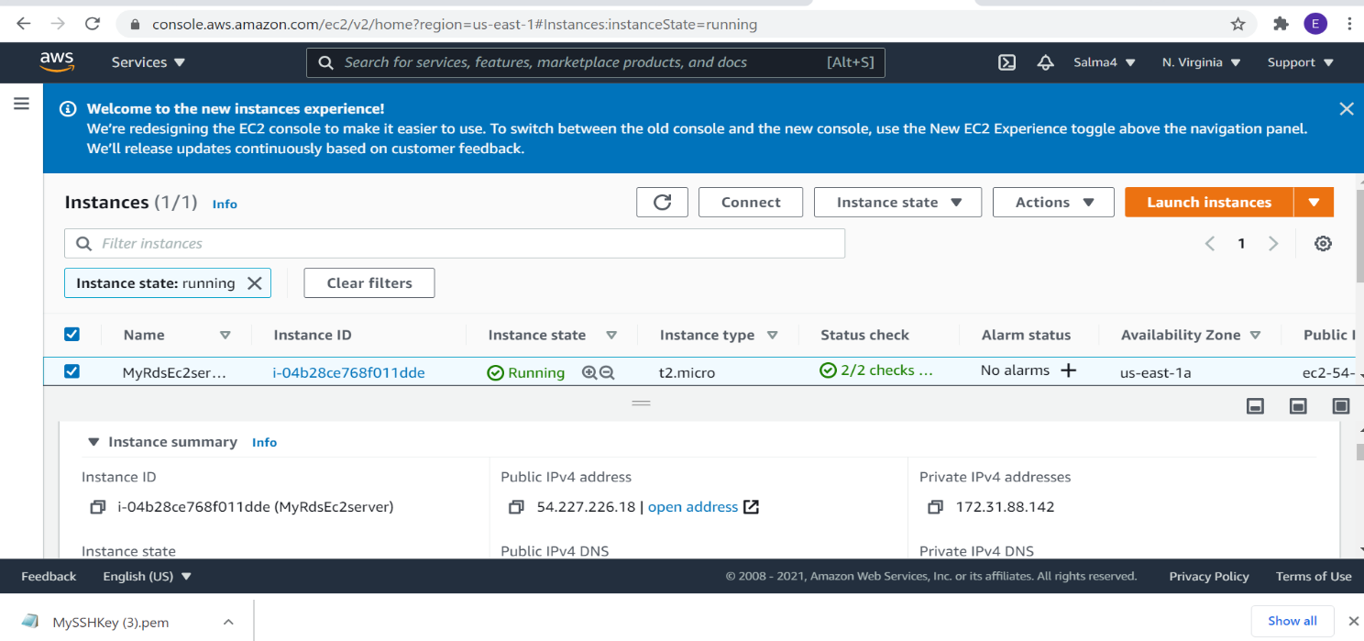

ScreenShot for User data field showing mysql installation:

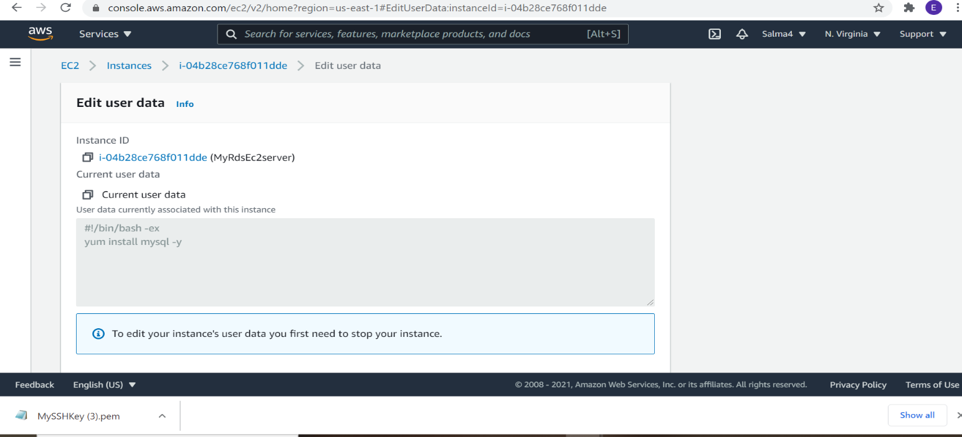
Create a Security Group for RDS instance:
- Make sure you are in the N.Virginia Region.
- Navigate to EC2 by clicking on the menu available under the section.
- On the left panel menu, select the security group under the Network & Security section.
- Click on the button.
- We are going to create a Security group for RDS with 3306 port number enabled.
  - Security group name : Enter rds-maz-SG
  - Description : Enter Security group for RDS Aurora
  - VPC : Select Default VPC
- Click on the button under Inbound rules.
  - In the textbox add 0.0.0.0/0
  - Source : Select Custom
  - Type : Select MYSQL/Aurora
6.Leave everything as default and click on the button.

ScreenShot for MyEC2 Server Security group:
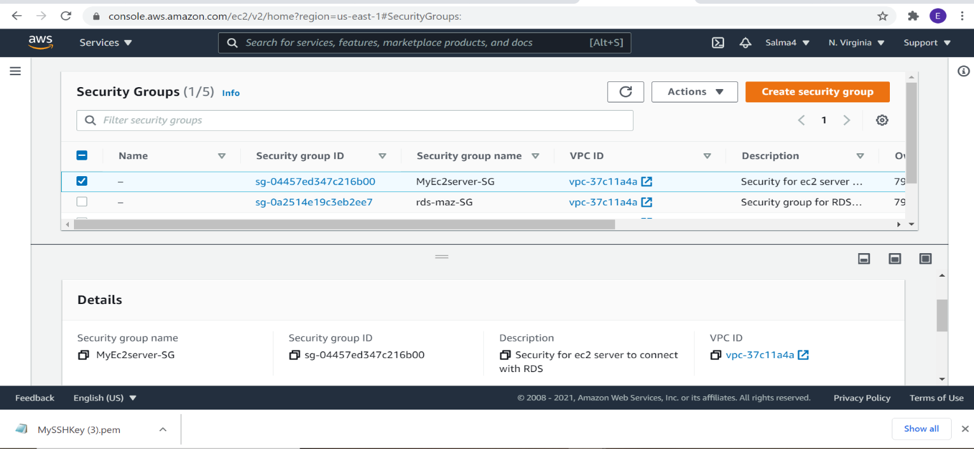

ScreenShot for Rds Security group:
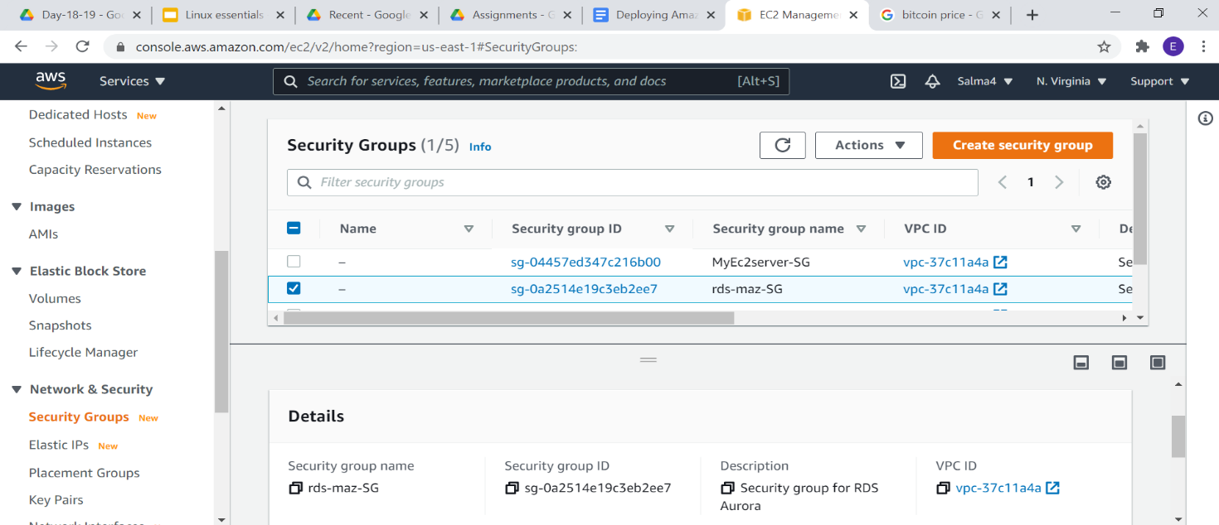
Create an Amazon Aurora database with Multi-AZ enabled
- Make sure you are in N.Virginia Region.
- Navigate to RDS under the database section of the Services menu
- Click on Databases in the left Panel.
- Click on .
- Ignore the warning mentioned below and continue with the next steps.
Note: If you are in the original interface, make sure to click on the Switch to the new database creation flow as shown below.
- Next we'll configure the database on the Create Database Page
  - Choose a Database Creation Method:
    - Select Standard Create
- In Engine options:
- Engine type : Choose Amazon Aurora
- Edition : Choose Amazon Aurora with MySQL compatibility
- Capacity Type : Provisioned
- Version : Default (Aurora (MYSQL 5.7) 2.07.2)
- Replication features:
  - Select Single-master (default)
- Choose Template: Dev/Test
- Fill in the required details for the database (Aurora Cluster Settings)
- DB cluster identifier: Specify cluster name MyAuroraCluster
- Give the following details in the credential settings
- Master Username: labsAdmin
- Master password: labs123
- Confirm password: labs123
- Note: This is the username and password used to log into your database. Please make note of them.
- Choosing DB instance size
- DB instance class: Choose Burstable classes (includes t classes)
- By Default, db.t3.small will be selected, please enable the option below of Include previous generation classes.
- Select db.t2.small instance.
- Note: Incase, db.t2.small is not available, we have added support for db.t3.small also, meaning you can go ahead with any of the two types.
- Availability and Durability: Choose Multi-AZ deployment: Create Aurora Replica or Reader node in a different AZ as shown below:

- Connectivity
  - Choose the Default VPC
- Additional connectivity configuration
  - Subnet group : Default
  - Publicly accessible : Yes
  - Existing VPC security groups :
    - Remove the Default security group, which is selected by default.
    - Select rds-maz-SG for the dropdown.(This is the security group which you have created in the beginning)
  - Database port : 3306
- Additional configuration:
  - Database options
    - Initial database name: whizlabsrds
  - Encryption : Uncheck
â€‹
- Leave other settings as default
- One the details above have been filled in, click on .
- It will take around 10-15 minutes for the database to be created. Please wait until database status changes from creating to Available.
- Once the database has been created, you should see the following page:
Similar to the screenshot, you should be able to see that our database launched in multiple AZs, namely us-east-1d and us-east-1e
Screenshot enabling multi AZs:
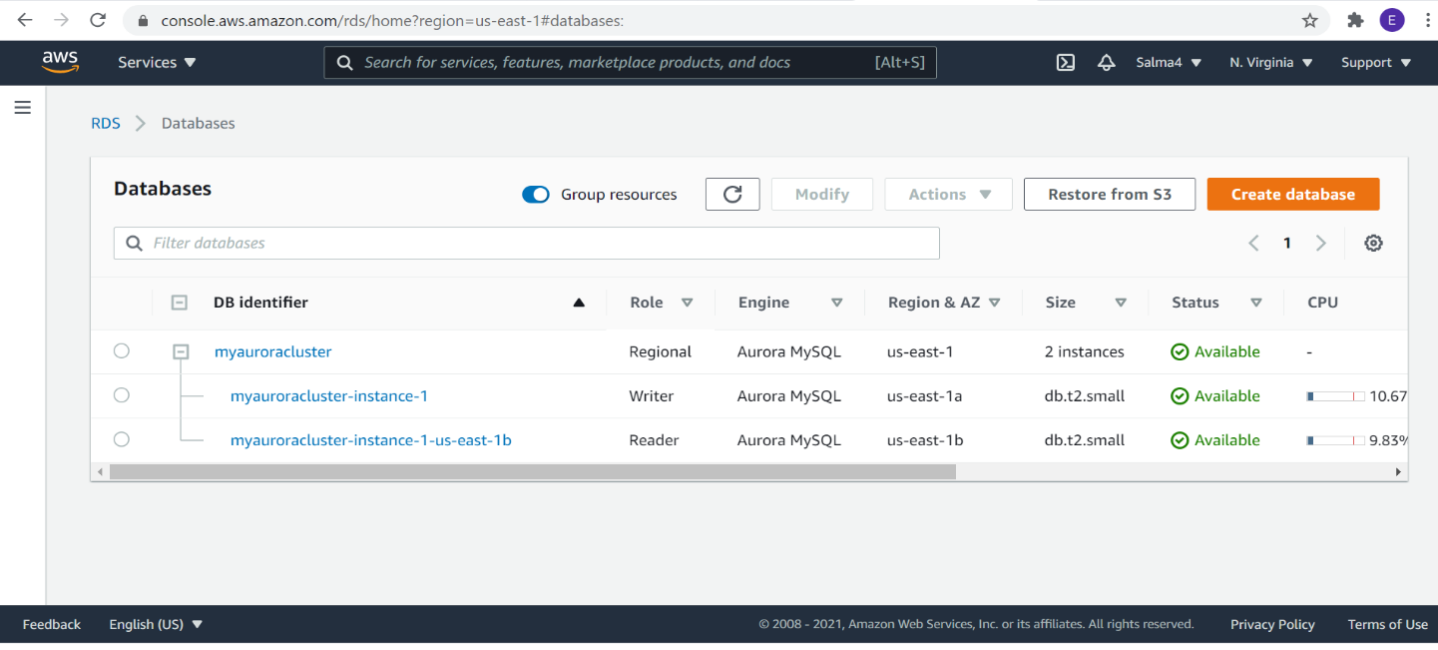

Connecting to the Aurora (MySQL) database on RDS
Now we have successfully launched Aurora RDS with Multi-AZ enabled. To connect to the new Aurora database, we need the endpoint.
- Click on the RDS cluster name and then navigate to Connectivity & security to find the endpoint of your Master(Writer) and Reader instances, with which you can connect to your DB instance.
- The endpoints you see to be similar to these examples:
Master(Writer): myauroracluster.cluster-cpoz6c7903cx.us-east-1.rds.amazonaws.com
Reader: myauroracluster.cluster-ro-cpoz6c7903cx.us-east-1.rds.amazonaws.com
Note: Please carefully look at the role of the DB instance ( reader vs Master(Writer)) and their respective availability zones. ( here us-east-1d and us-east-1e )
- To get the endpoint of the RDS instances, click on the name of the cluster. Then you should click on Endpoints. This will expose the read and write endpoints for the database. See the example below:
Screenshot for the endponts:

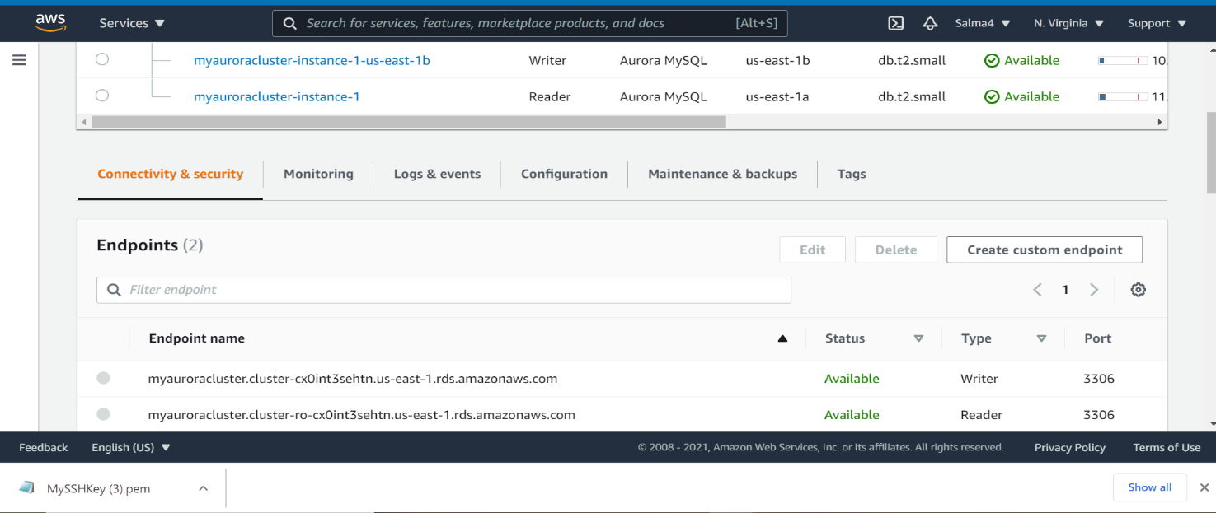
Connecting the EC2 Server to RDS:
- Now we need to connect the RDS with ec2 server in order to eventually connect with the Aurora database.
- Navigate to RDS available under the database section of the Services menu.
- Click on Master (writer) database and click on the security group name in this example it is rds-maz-SG under VPC security groups as shown below:
- It will open the Security Group page. Click on InBound.
- The MySQL rule will already exists.
- Under source, delete any pre-populated IP Address and enter the private IP of your MyRdsEc2server EC2 instance with CIDR /32 (EC2 instance Private IP) and then click as shown below:

Execute Database Operations via SSH
- Copy the IPv4 Public IP address , navigate to the EC2 Dashboard and look in the instance details.
- SSH into the EC2 instance we just created through the following steps in SSH into EC2 Instance.
- Switch to the root user using the command : sudo -s
- Log into the RDS instance using the below command:
- Syntax: mysql -h <Hostname> -u <username> -p
Note: Make sure to change the above Master(Writer)Cluster endpoint and Username with your's.
- Host name : myauroracluster.cluster-cpoz6c7903cx.us-east-1.rds.amazonaws.com (Master(Writer)cluster endpoint)
- Username : labsAdmin
- Password : labs123 (Use yours incase you changed the password while creating RDS)
- Database name : labsrds
- You should now be able to log into the database, as shown below:
Screenshot of connecting to the database:

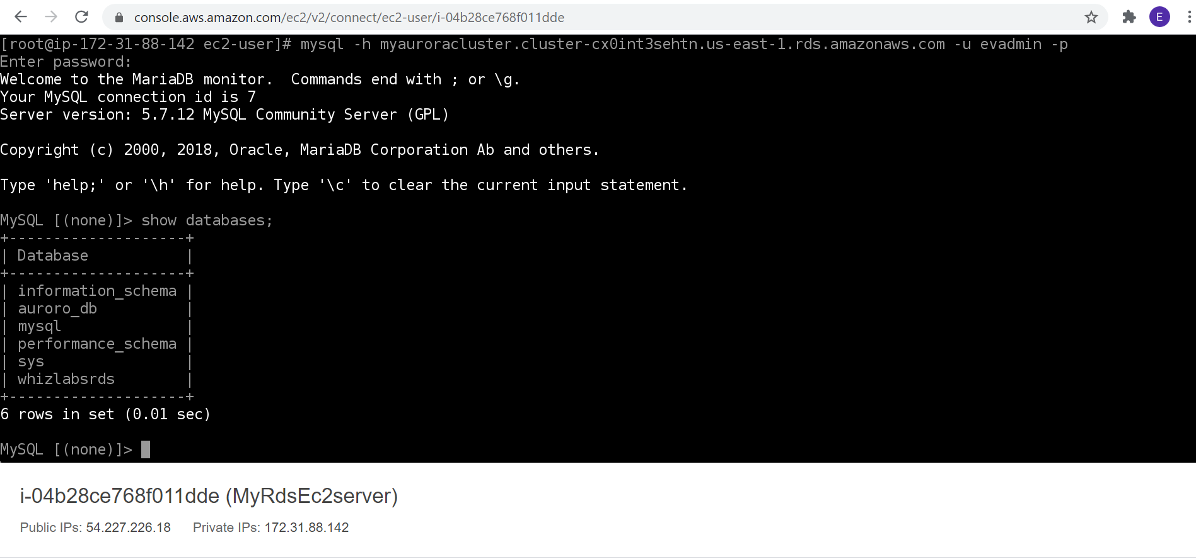

- List all Databases:

- Show databases;
Now you will see the database labsrds created while launching the RDS cluster.
- Now create the database in the Master(Writer) RDS as given in the screenshot. We'll create a demo database named auroro_db.
- Create database auroro_db;
- Select the newly-created database:
- use auroro_db;
- Next we'll create a table named students and insert few rows of data using list of commands:
- CREATE TABLE students ( subject_id INT AUTO_INCREMENT, subject_name VARCHAR(255) NOT NULL, teacher VARCHAR(255),start_date DATE, lesson TEXT,PRIMARY KEY (subject_id));
- Insert data into the table:
- INSERT INTO students(subject_name, teacher) VALUES ('English', 'John Taylor');
- INSERT INTO students(subject_name, teacher) VALUES ('Science', 'Mary Smith');
- INSERT INTO students(subject_name, teacher) VALUES ('Maths', 'Ted Miller');
- INSERT INTO students(subject_name, teacher) VALUES ('Arts', 'Suzan Carpenter');
- Now you can view the contents of the table student using the below command:
- select * from students;

Screenshot of the student database created;
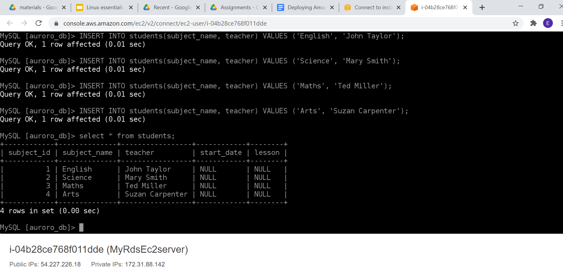

- Exit from mysql console use the below command:
  - exit
Forcing a Failover to Test Multi-AZ
- To test if Multi-AZ is working, we will create a situation where master fails and the read replica has to become the new Master(Writer).
- On the next screen, confirm the Failover.
- Wait for a few minutes for the RDS instances to failover.
- ( i.e Master(Writer) becomes Reader and Reader becomes Master(Writer) as shown below )
Screenshot forcing Failover:

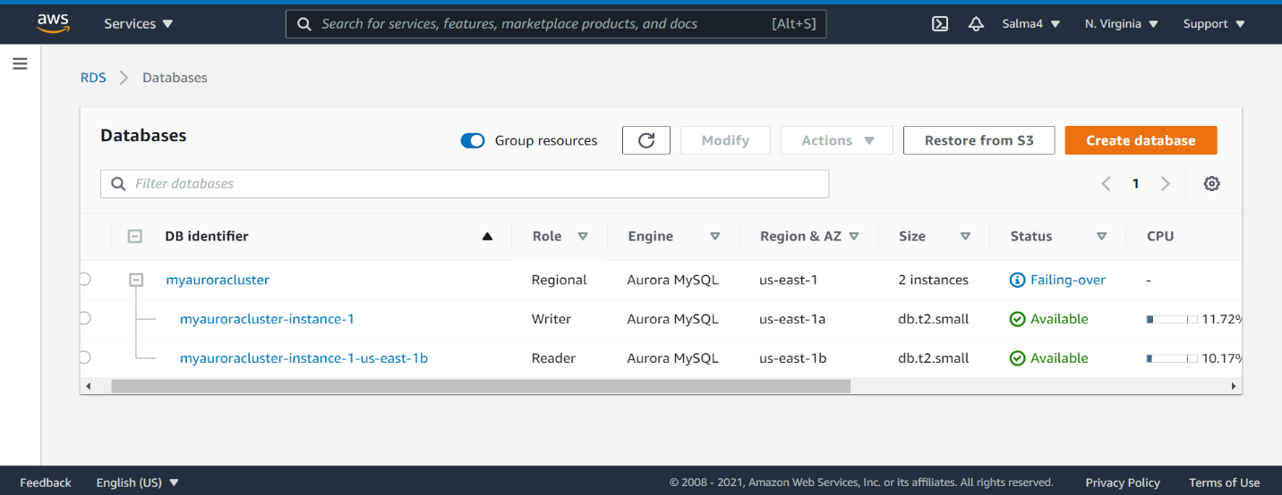

Screenshot After Failover , the reader switched become the writer and writer became the reader:
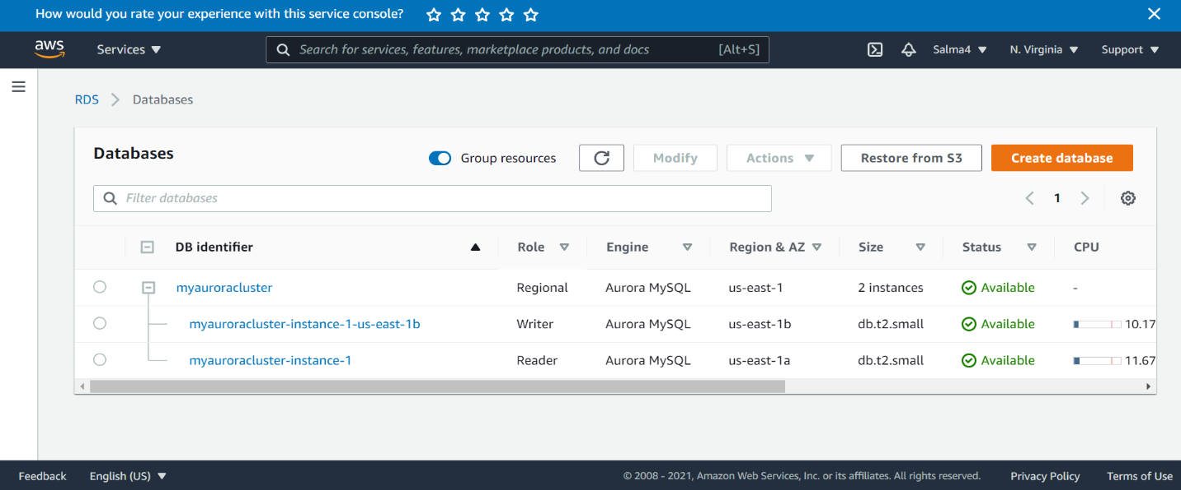

Testing the Failover Condition
- Now connect to RDS with new Master endpoint
  - Copy the endpoint of the new Master(Writer)cluster and replace it with your endpoint link.
Mysql -h <endpoint> -u <username> -p and press [Enter]
- mysql -h myauroracluster.cluster-cpoz6c7903cx.us-east-1.rds.amazonaws.com -u labsAdmin -p
password: labs123
- You will be able to Log into MySQL and check for the database and table created in the master DB instance before the failover.
You can notice the resources created on the original master db are present, implying that the Failover worked successfully.
- Show databases;
- use auroro_db;

- Now check the existence of table named students and data (that we created earlier in the lab):
  - show tables;
  - select * from students;
- Now if you want you can insert new data into the table students.
  - INSERT INTO students(subject_name, teacher) VALUES ('Spanish', 'Isabella');
  - select * from students;
Screenshots of connection to database after failover using the endpoint;
The log in was successful as shown below :

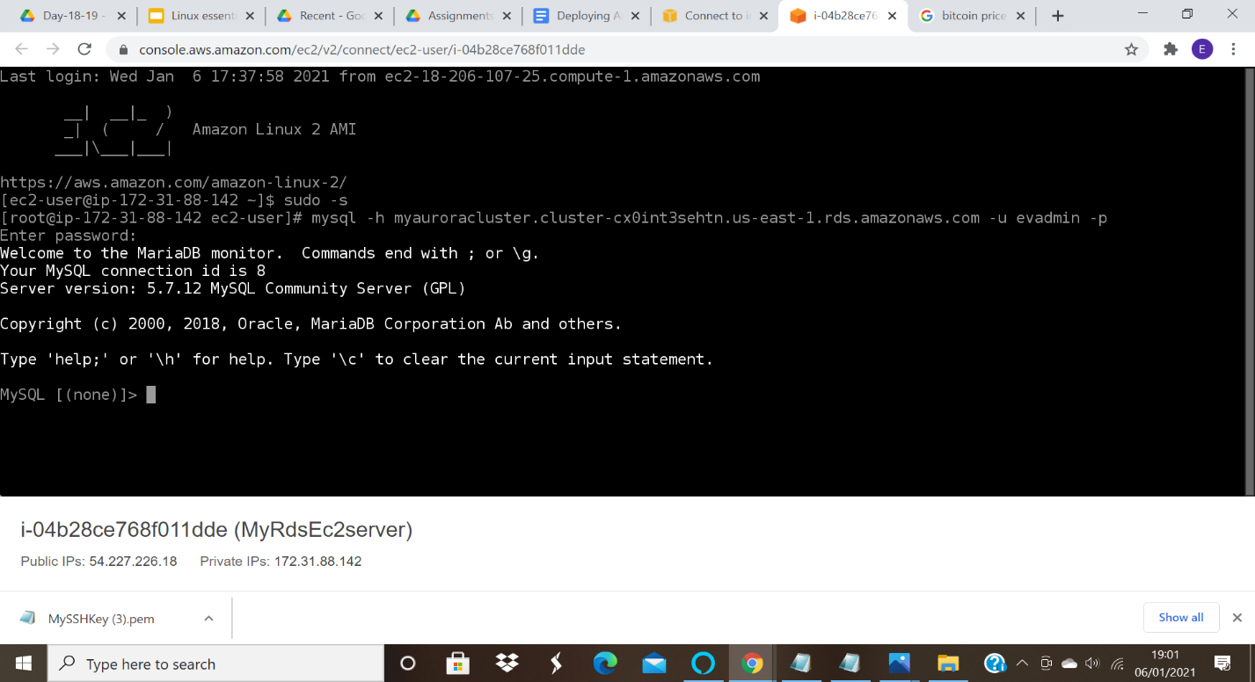

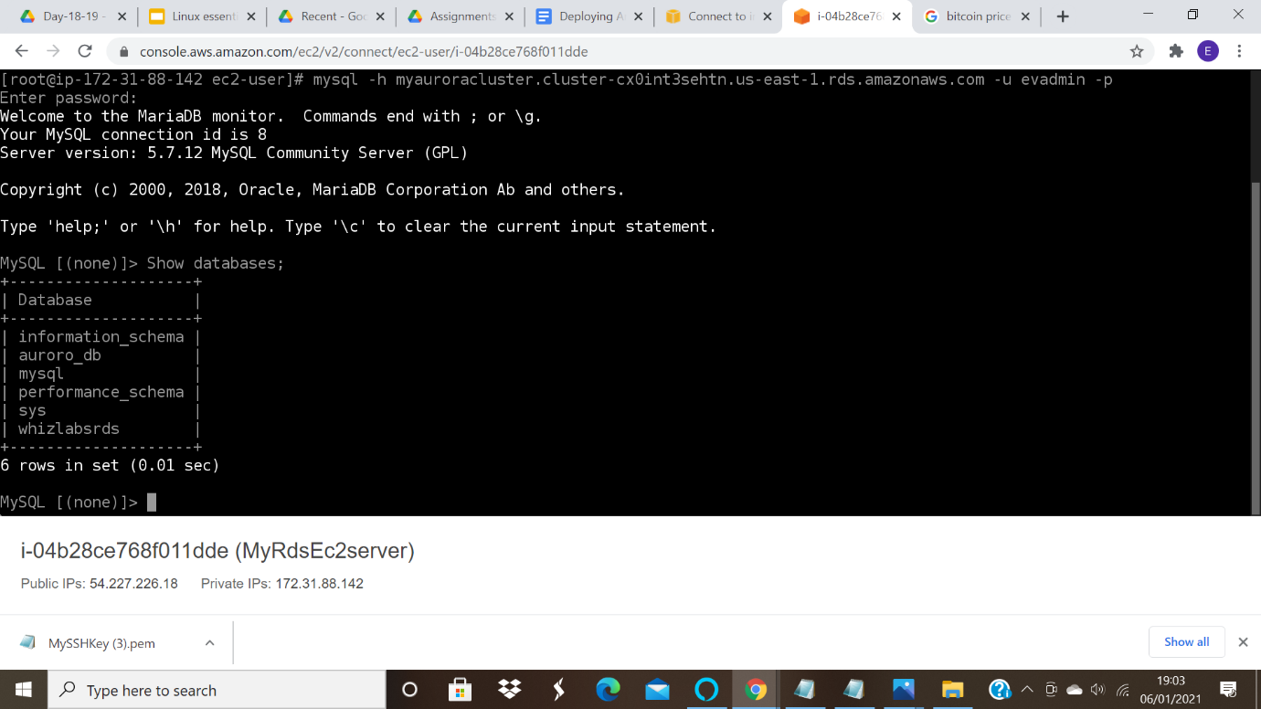

Screenshot of database after failover:
